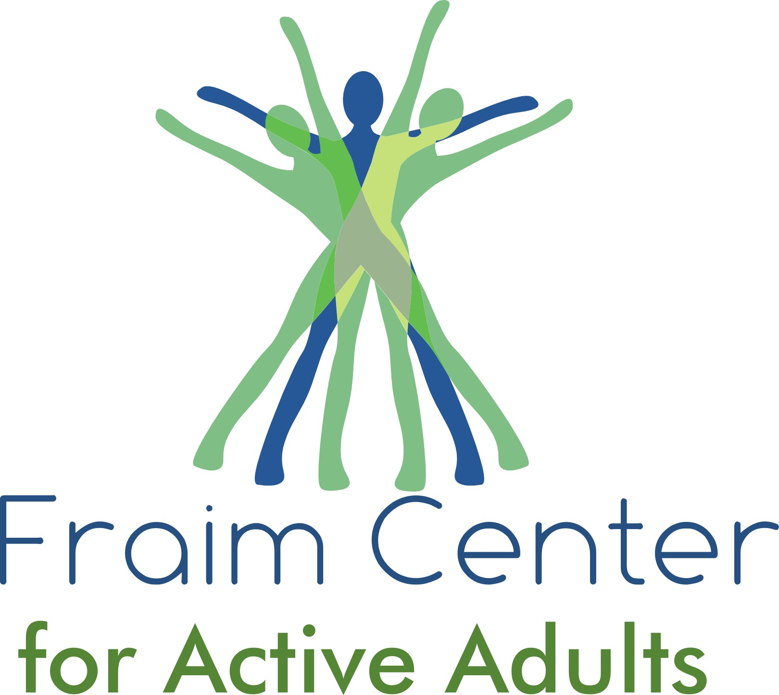

While the Pool is CLOSED in April and May, there will be some new Fitness Classes. Below is the Fitness Class schedule beginning Monday, 4/3:

Fitness Class Schedule-April & May 2023
Fitness Room Open 6:00 am-1:00 pm (Monday-Friday)
Fitness Room will be closed on Saturday's!

Monday
- 7:30 am-8:10 am - Strength & Mobility (Large Gym-Barb)
- 8:20am-8:50am –Tai Chi Chih (Teen Center-Barb)
- 9:00 am-10:00 am - Yoga (Teen Center-Sahr)
- 10:00 am-11:00 am - Chair Arthritis-New (Teen Center-Mary)
Tuesday
- 8:00 am-8:45 am - Intervals (Large Gym-Casey)
- 8:30 am-9:00 am - Awaken-New (Teen Center-Barb)
- 9:00 am-9:30 am - Blast ABS & Core (Large Gym-Casey)
- 9:05 am-9:35 am - Stability Ball-New (Teen Center-Barb)
- 9:30 am-10:30 am - ZUMBA (Large Gym-Sandy)
- 9:40 am-10:15 am - T’ai Chi Chi (Teen Center- Barb)
- 10:45 am-1:00 pm - Pickleball (Large Gym)
- Between 9:00 am & 10:00 am - MAHJONGG (Coffee Room)
Wednesday
- 7:30 am-8:10 am - Strength & Mobility (Large Gym-Barb)
- 8:20am-8:50am- Tai Chi Chih (Teen Center-Barb)
- 9:00 am-10:00 am - Chair Yoga (Teen Center-Jacqueline)
- 10:45 am-1:00 pm - Pickleball (Large Gym)
- Between 9:00 am & 10:00 am - Pinochle (Coffee Room)

Thursday
- 8:00 am-8:45 am - Intervals (Large Gym-Casey)
- 9:05 am-9:35 am - Stability Ball-New (Teen Center-Barb
- 9:00 am-9:30 am - Blast ABS & Core (Large Gym-Casey)
- 9:30 am-10:30 am - ZUMBA (Large Gym-Sandy)
- 9:40 am-10:15 am - T’ai Chi Chi (Teen Center- Barb)
- 10:45 am-1:00 pm - Pickleball (Large Gym)
Friday
- 7:30 am-8:10 am - Strength & Mobility (Large Gym-Barb)
- 9:00 am-10:00 am - Yoga (Teen Center- Sahr)
- 10:00 am-11:00 am - Chair Arthritis-New (Teen Center-Mary)

Class Descriptions:
- You can request a copy of the description of Fitness classes we've had in place for some time by contacting the office by phone or email.

Description of New Classes Above:
- Chair Arthritis - This class is a group exercise utilizing a chair and small beach balls. It is designed to help with balance, pain, stiffness, mobility, and functional ability.
- Awaken - This class uses a chair and targets all of the major Energy Centers (via Meridians, an energetic highway in the human body) through gentle stretching techniques which reawaken Radiance, Vitality, Gratitude and an inner sense of Awe. The perfect beginning to a good day!
- Stability Ball - Strength and Core stability are challenged using the large Medicine Ball and free weights in this fast moving, fun class.

